TASKS ON RDS

1. Create MariaDB DB on EC2

PURPOSE: The purpose of creating a MariaDB database on an AWS EC2 instance is to provide a reliable and scalable relational database service for storing, managing and retrieving application data.

OBJECTIVE: The objective of creating a MariaDB database on an AWS EC2 instance is to install, configure and manage a relational database server that can securely store, organize and provide access to application data within the AWS cloud environment.

PREREQUISITES:

- An active AWS account.
- IAM user with permissions to create and manage EC2 instances, Security Groups, and EBS volumes.
- A configured AWS Region where resources will be deployed.

OUTCOME: A fully functional and secure MariaDB database is deployed on an EC2 instance, enabling reliable storage, management, and access to application data in AWS.

STEP BY STEP IMPLEMENTATION:
- We have to setup one database in our EC2 instance.
- So for that we have create a user and set password for that user.
- Then we have to set up the mySQL user and password.
- After that set all the permissions and privileges to the user.

Database Setup on EC2 Instance:
- echo "CREATE DATABASE ${DBName};" >> /tmp/db.setup
- echo "CREATE USER '${DBUser}' IDENTIFIED BY '${DBPassword}';" >> /tmp/db.setup
- echo "GRANT ALL PRIVILEGES ON *.* TO '${DBUser}'@'%';" >> /tmp/db.setup
- echo "FLUSH PRIVILEGES;" >> /tmp/db.setup
- mysqladmin -u root password "${DBRootPassword}"
- mysql -u root --password="${DBRootPassword}" < /tmp/db.setup
- rm /tmp/db.setup

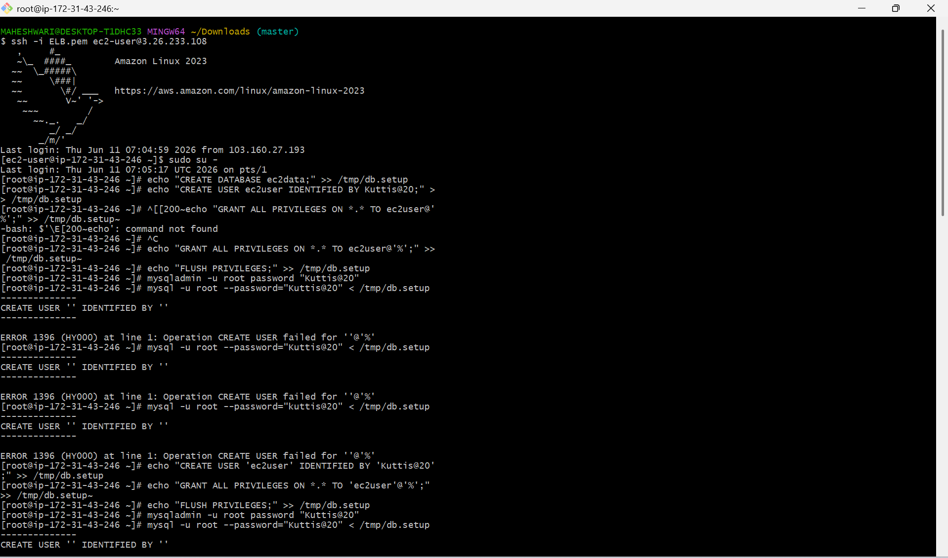

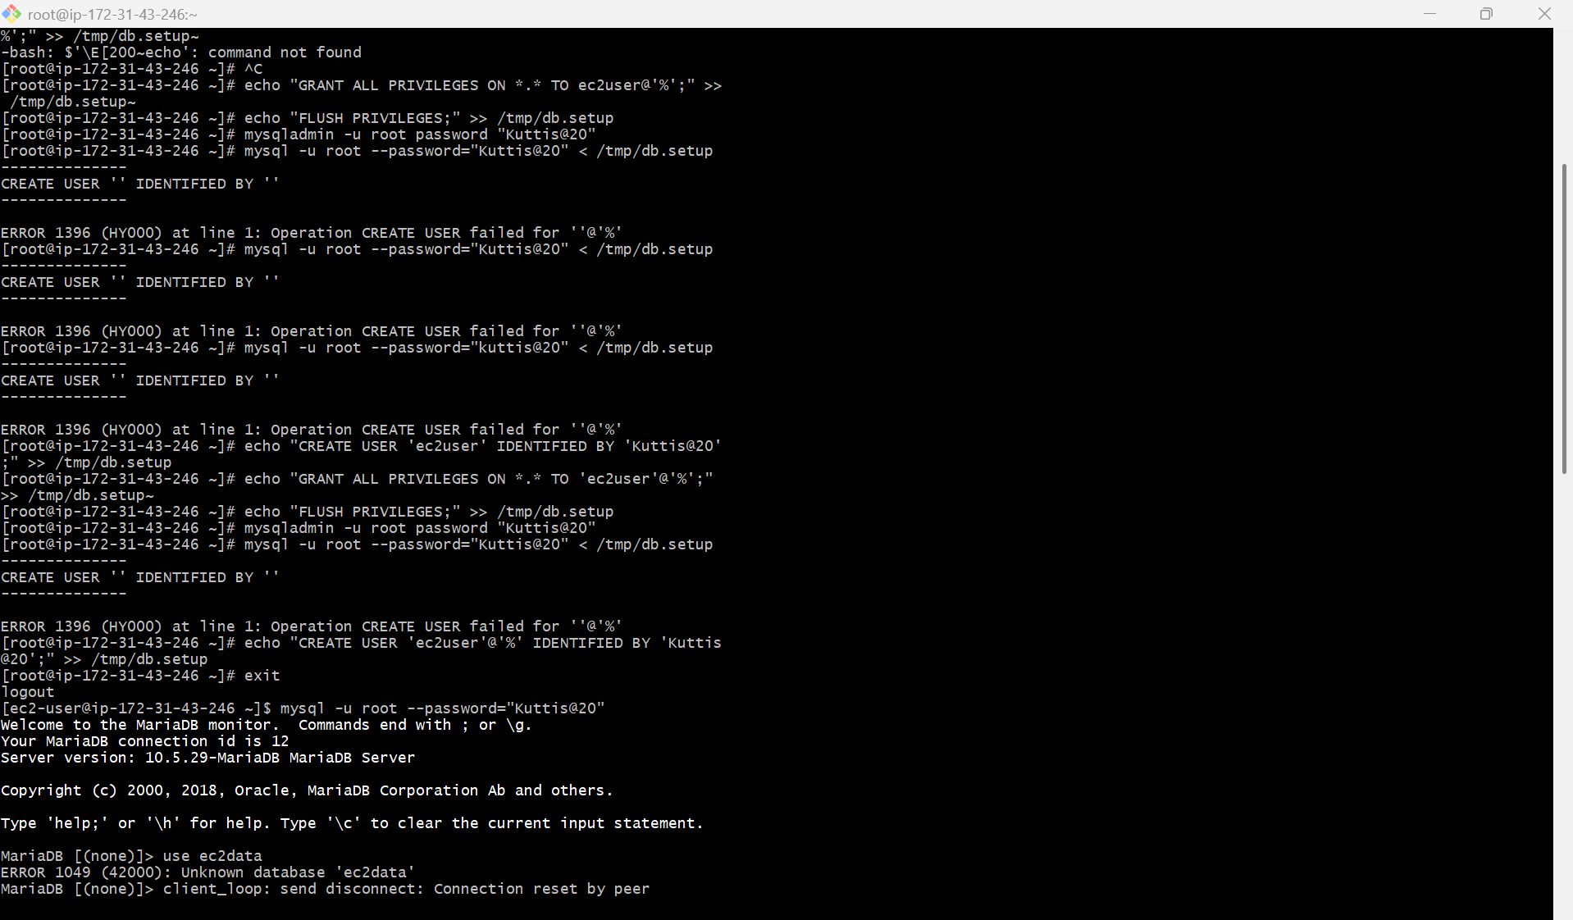

2. Insert some dummy data.

OBJECTIVE: The objective of inserting dummy data is to populate a database table with sample records for testing, validation and demonstration purposes before using real production data.

STEP BY STEP IMPLEMENTATION:
- insert the data into the created database.
- Before that we have to login into the mariadb database.
- That’s where we can insert our dummy data into the database.
- First of all create table with the specific name.
- After that we have to give the datatypes like INT, VARCHAR like this.
- After this we have to insert the values into the table.

COMMANDS USED TO ADD THE DATA

- mysql -u root --password="${DBRootPassword}"
- USE ec2db;
- CREATE TABLE table1 (id INT, name VARCHAR(45));
- INSERT INTO table1 VALUES(1, 'Virat'), (2, 'Sachin'), (3, 'Dhoni'), (4, 'ABD');
- SELECT * FROM table1;

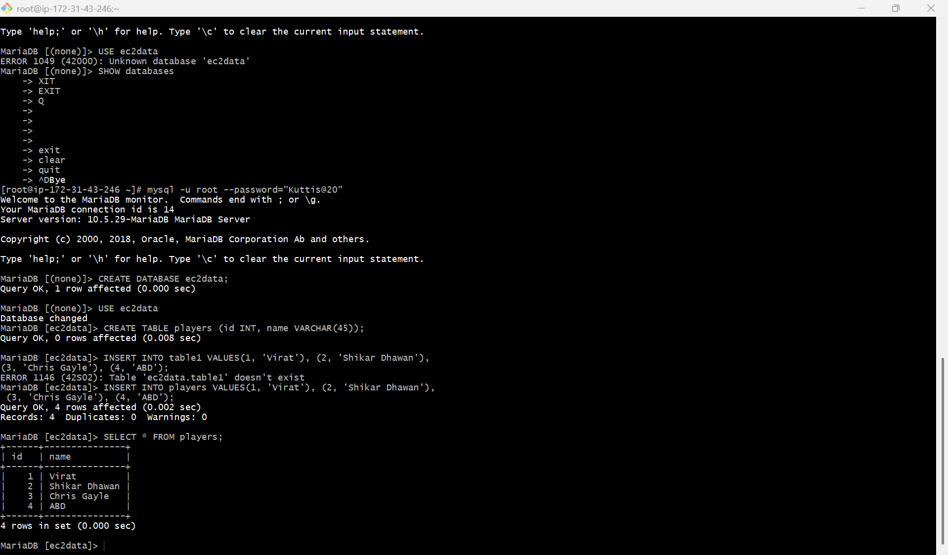

3. Take the backup of dummy data on EC2.

PURPOSE: The purpose of taking a backup of dummy data on an EC2 instance is to create a copy of the database data that can be restored in case of accidental deletion, corruption, testing failures or system issues.
OBJECTIVE: The objective of taking the backup of dummy data on an EC2 instance is to create and store backup copy of the database so that the data can be recovered, restored or migrated whenever required.
STEP BY STEP IMPLEMENTATION:
- Take the backup of the database -> mysqldump -u root -p database_name > file_name.sql
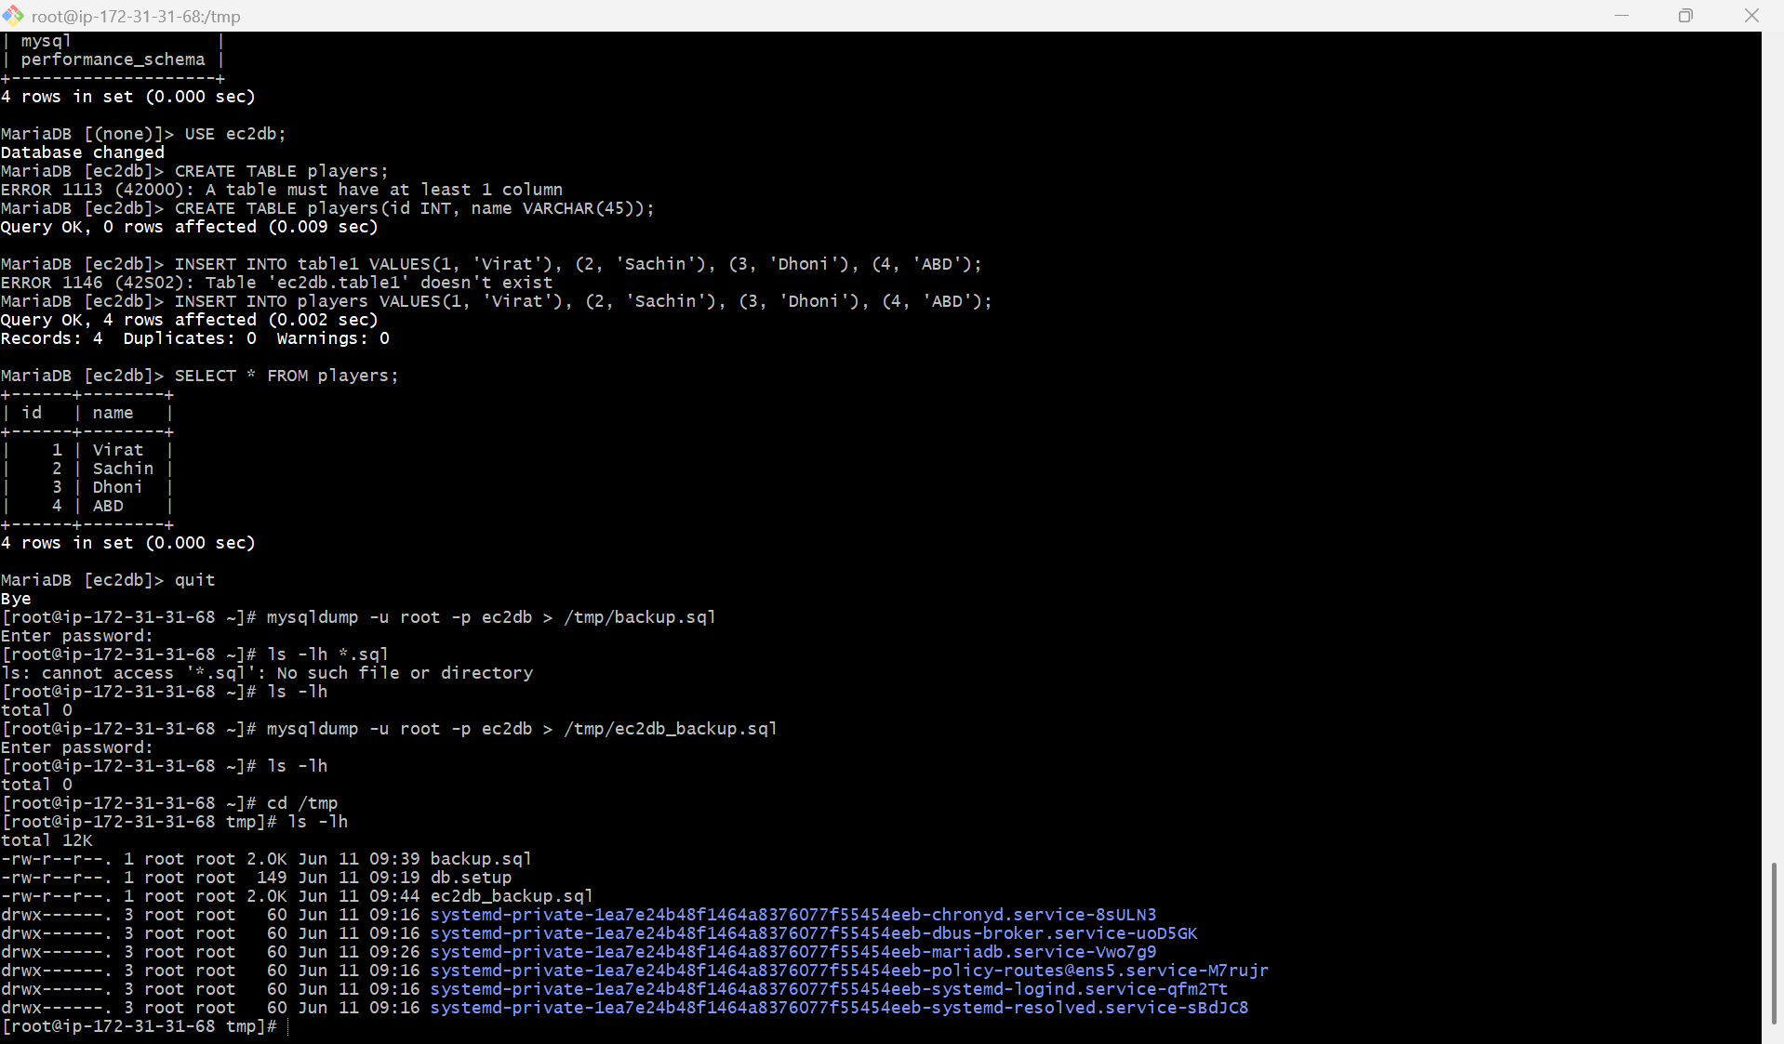

4. Launch MariaDB RDS instance.

PURPOSE: The purpose of launching a MariaDB RDS instance is to deploy a fully managed relational database service in AWS, allowing users to store, manage, and access application data without handling the underlying database infrastructure.

OBJECTIVE: The objective of launching a MariaDB RDS instance is to provision and configure a managed MariaDB database service on AWS that can securely store, manage and provide access to application data with minimal administrative effort.

STEP BY STEP IMPLEMENTATION:
- Go to RDS service in AWS, and create a new RDS.
- In that we have to select the MariaDB database.
- And we have to select fully configured option and free tier for testing purpose.
- Then we have to select the self manage option give the user name and password.
- After this we have select the VPC and security group.
- Click on create RDS instance.
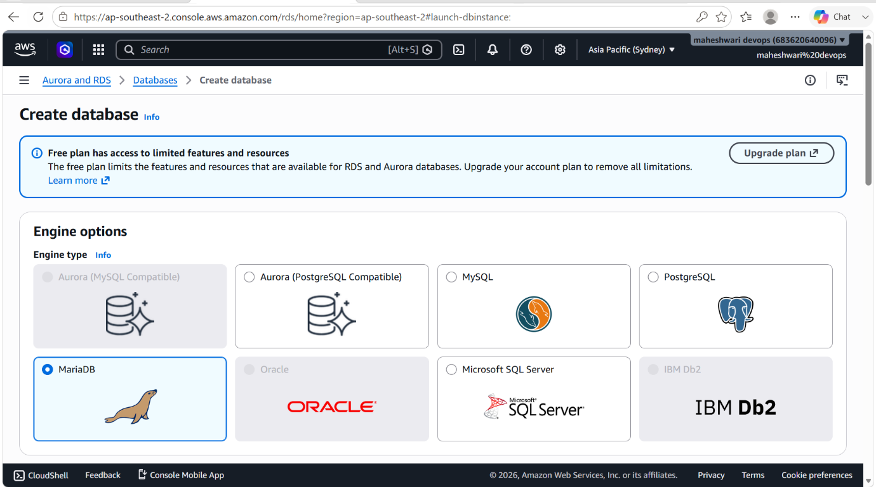

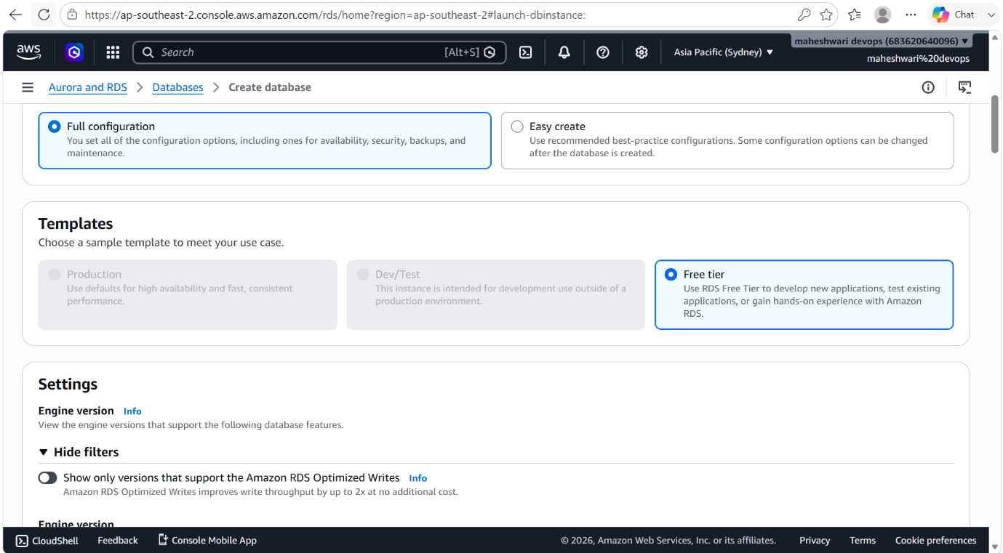

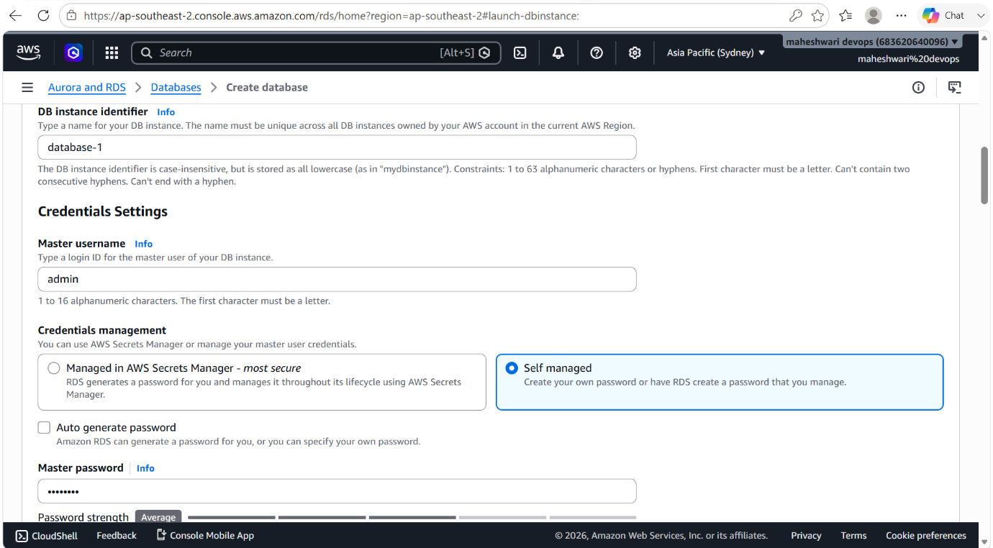

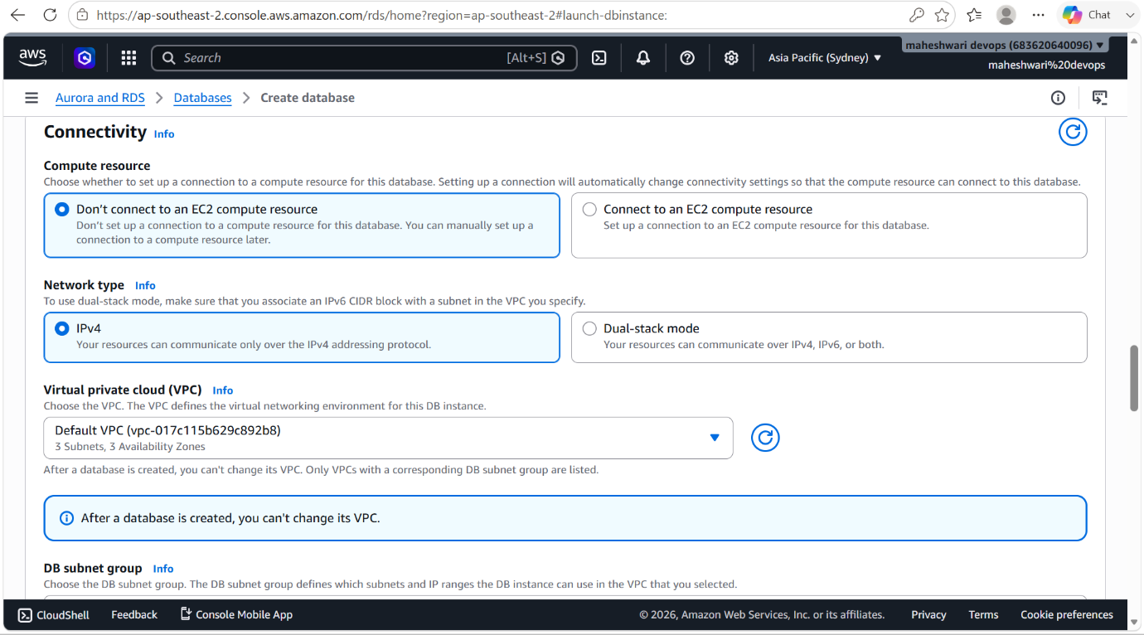

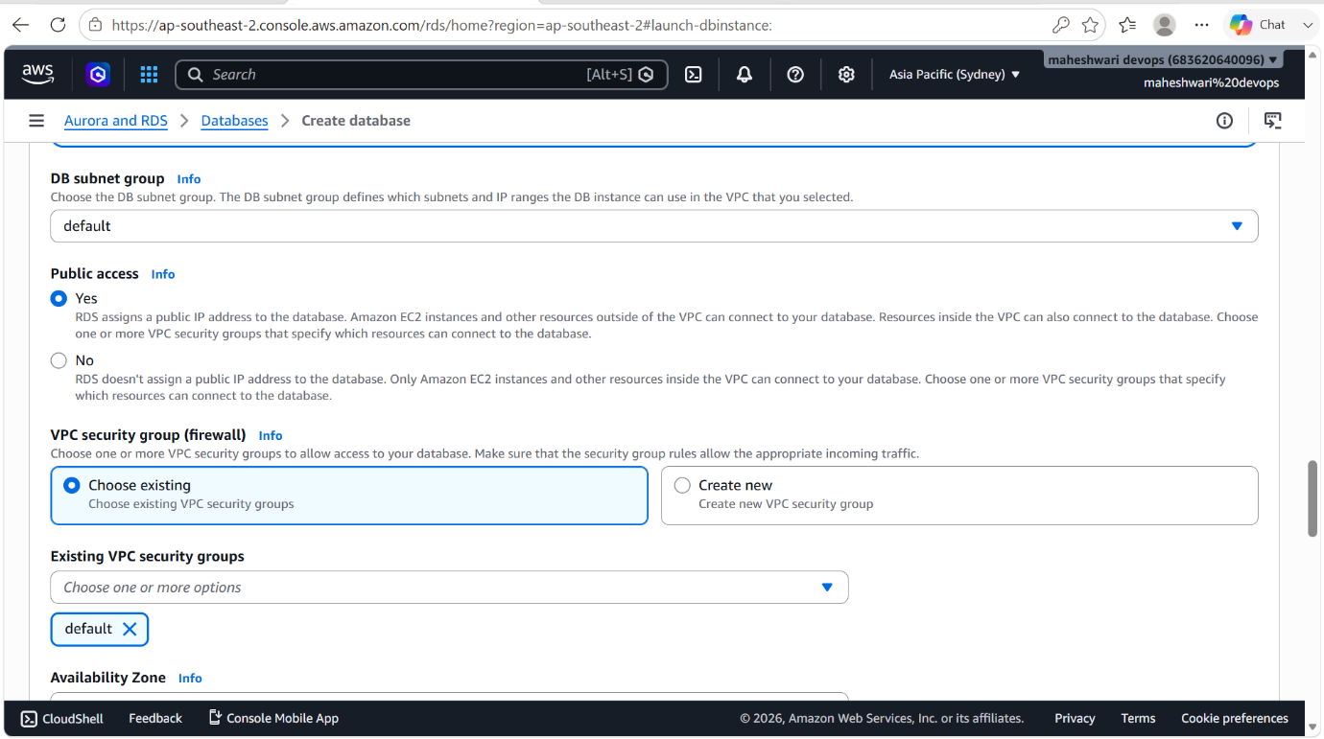

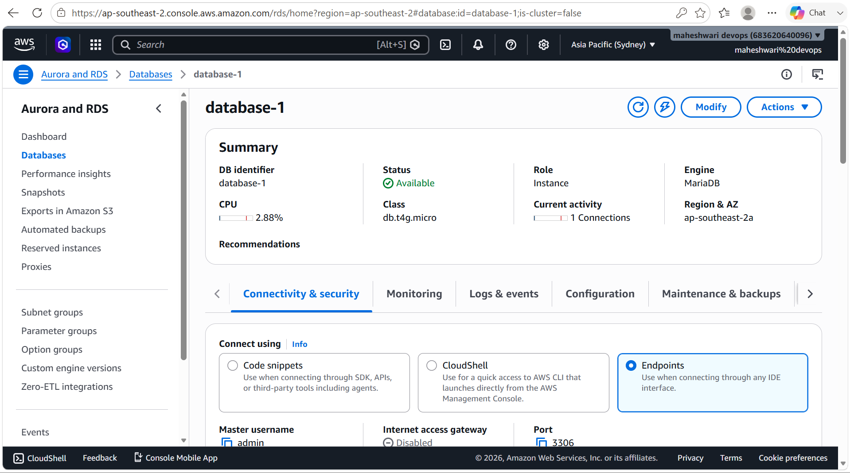

5. Migrate database from EC2 to RDS.

PURPOSE: The purpose of migrating a database from an EC2 instance to an AWS RDS MariaDB instance is to move from a self-managed database environment to a fully managed database service, reducing administrative overhead and improving scalability, availability, security, and reliability.

OBJECTIVE: The objective of migrating a database from an EC2 instance to an AWS RDS instance is to transfer the database schema, tables, and data to a managed database environment while ensuring data integrity, availability, and minimal disruption to applications.

OUTCOME: A fully functional database is successfully migrated from EC2 to AWS RDS, providing improved manageability, scalability, security, and reliability with minimal administrative effort.

STEP BY STEP IMPLEMENTATION:
- First of all create a database in the RDS instance that we have created in the earlier step.
- For this we have login into our RDS instance by using the endpoint.
- mysql -h database-1.clsgwmimec7q.ap-southeast-2.rds.amazonaws.com -P 3306 -u admin -p –ssl
- after the successful login, we have to create a database by using command -> CREATE DATABASE <database name>;
- after creating, get exit from the RDS instance and in the EC2 instance we have to dump the backup db to RDS instance db.
- mysql -h <replace-rds-end-point-here> -P 3306 -u <user_name> -p database_name < ec2db.sql –ssl

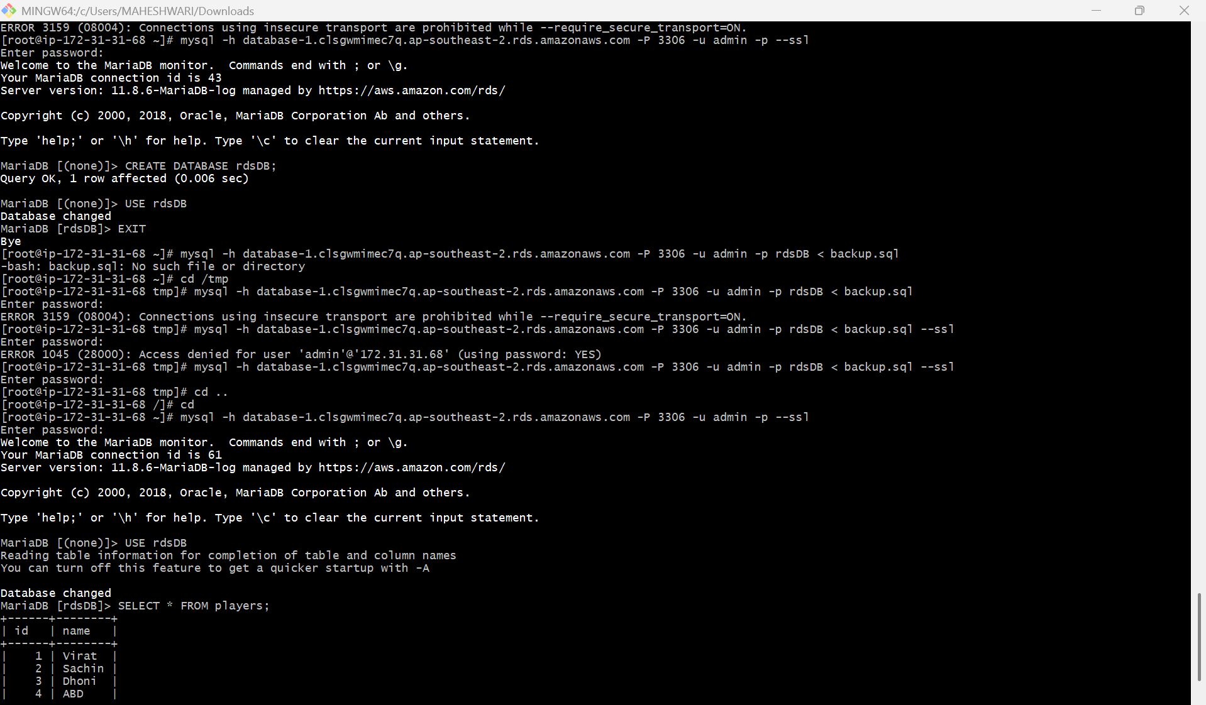

6. Install MySQL DB on EC2.

PURPOSE: The purpose of installing a MYSQL database on an AWS EC2 instance is to create a relational database environment for storing, managing and retrieving application data while gaining full over database configuration and administration.

OBJECTIVE: The objective of installing a MySQL database on an AWS EC2 instance is to set up and configure a relational database server that can securely store, manage, and provide access to application data.

OUTCOME: A fully functional and secure MySQL database is successfully deployed on an EC2 instance, enabling reliable storage, management, and access to application data in AWS.

STEP BY STEP IMPLEMENTATION:
- we have to some some commands to secure our mariadb that we have used earlier and after that only we can download MYSQL.
- sudo mysql_secure_installation
- before executing this command, we have to add inbound rules in security group of instance
MYSQL myIP
- now we can connect to our SQL -> mysql -u root -p

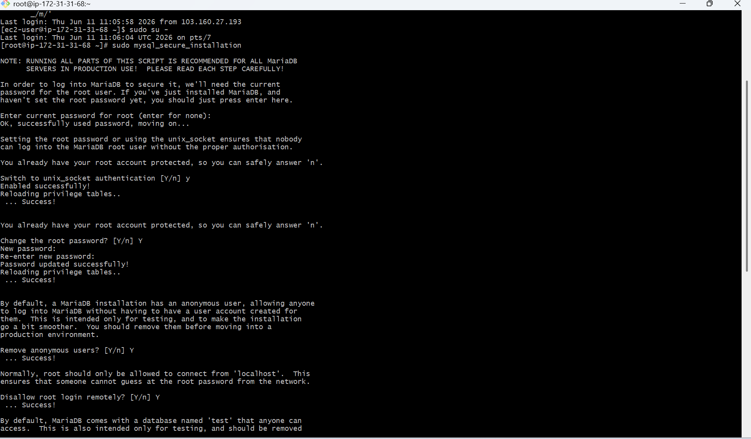

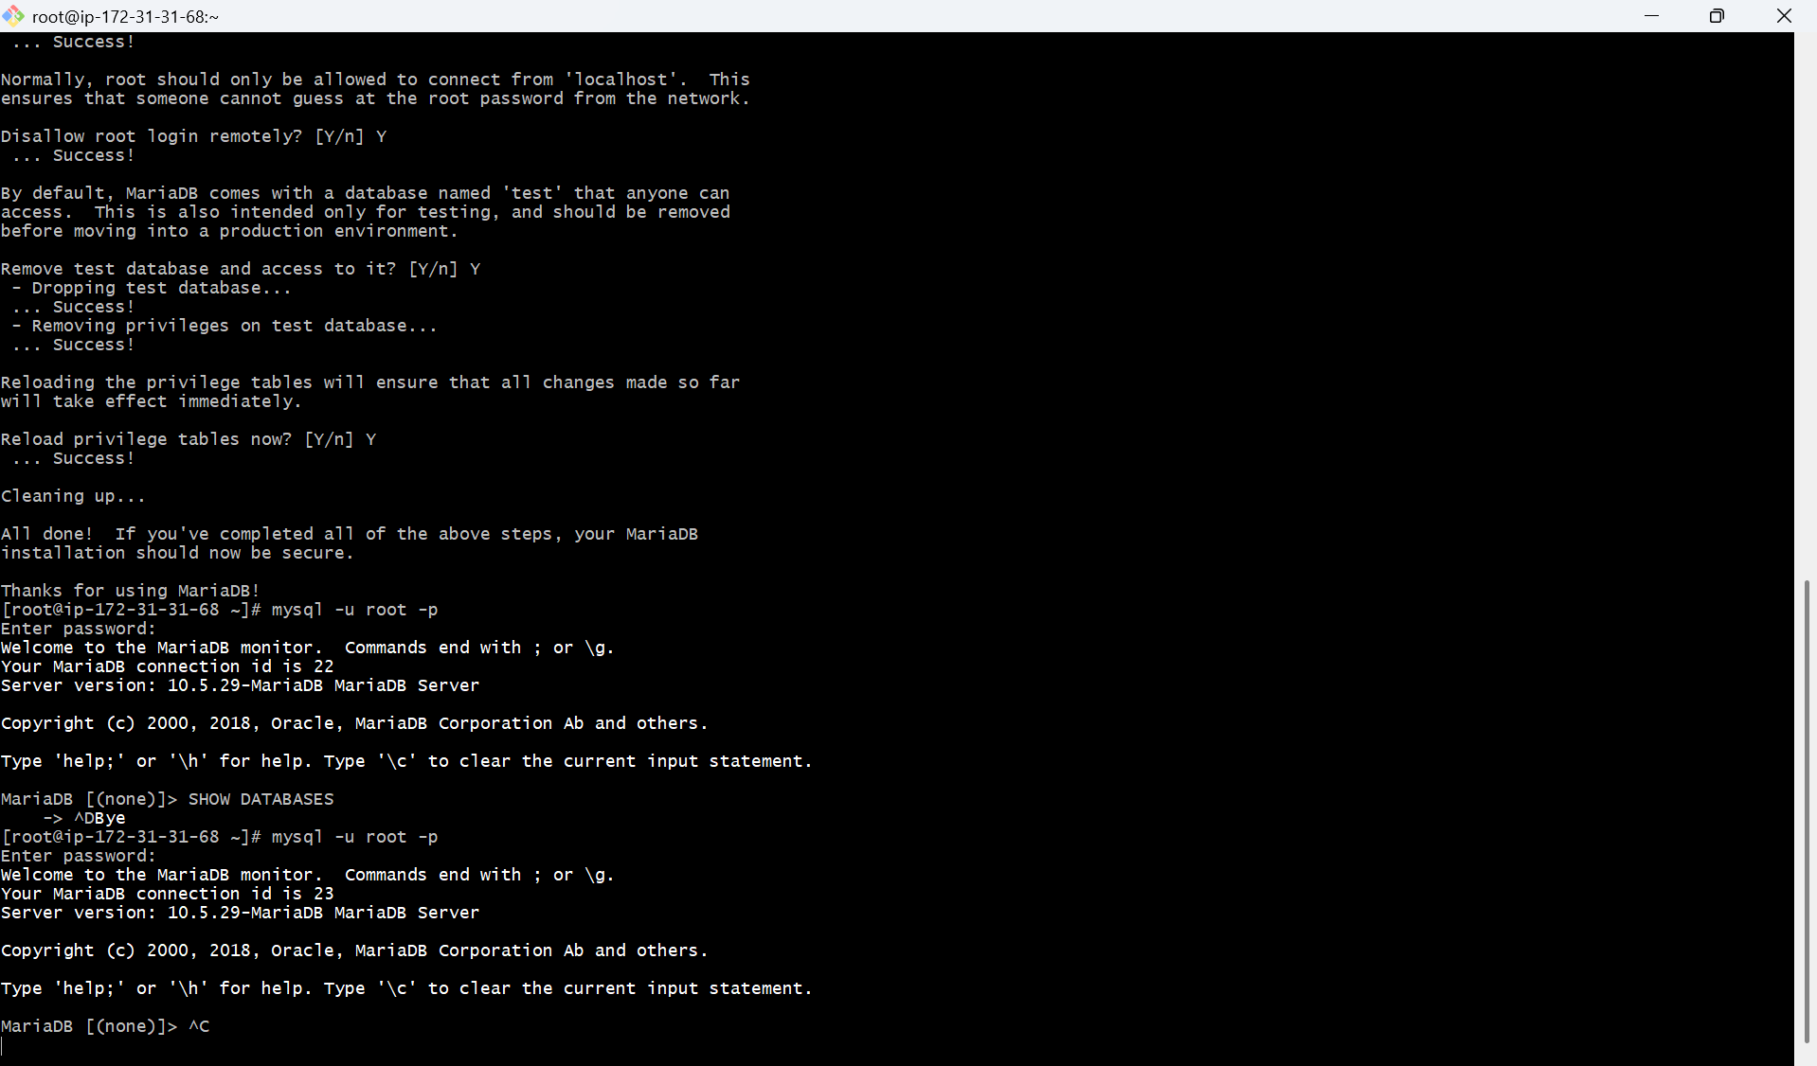

7. Launch MySQL RDS image.

PURPOSE: The purpose of launching a MYSQL RDS instance is to deploy a fully managed MySQL database service on AWS that provides secure, scalable and highly available database storage without requiring manual requiring manual database server administration.
OBJECTIVE: The objective of launching a MYSQL RDS instance is to provision and configure a managed MySQL database on AWS that can securely store, manage and provide access to application data while leveraging AWS managed database features.

OUTCOME: A fully managed MySQL database is successfully deployed on AWS RDS, providing secure, scalable, highly available, and reliable data storage with reduced administrative effort.

STEP BY STEP IMPLEMENTATION:
- create RDS instance by using MYSQL.
- For this we have login into our RDS instance by using the endpoint.
- mysql -h database-1.clsgwmimec7q.ap-southeast-2.rds.amazonaws.com -P 3306 -u admin -p –ssl
- after the successful login, we have to create a database by using command -> CREATE DATABASE <database name>;
- after creating, get exit from the RDS instance and in the EC2 instance we have to dump the backup db to RDS instance db.
- mysql -h <replace-rds-end-point-here> -P 3306 -u rdsuser -p

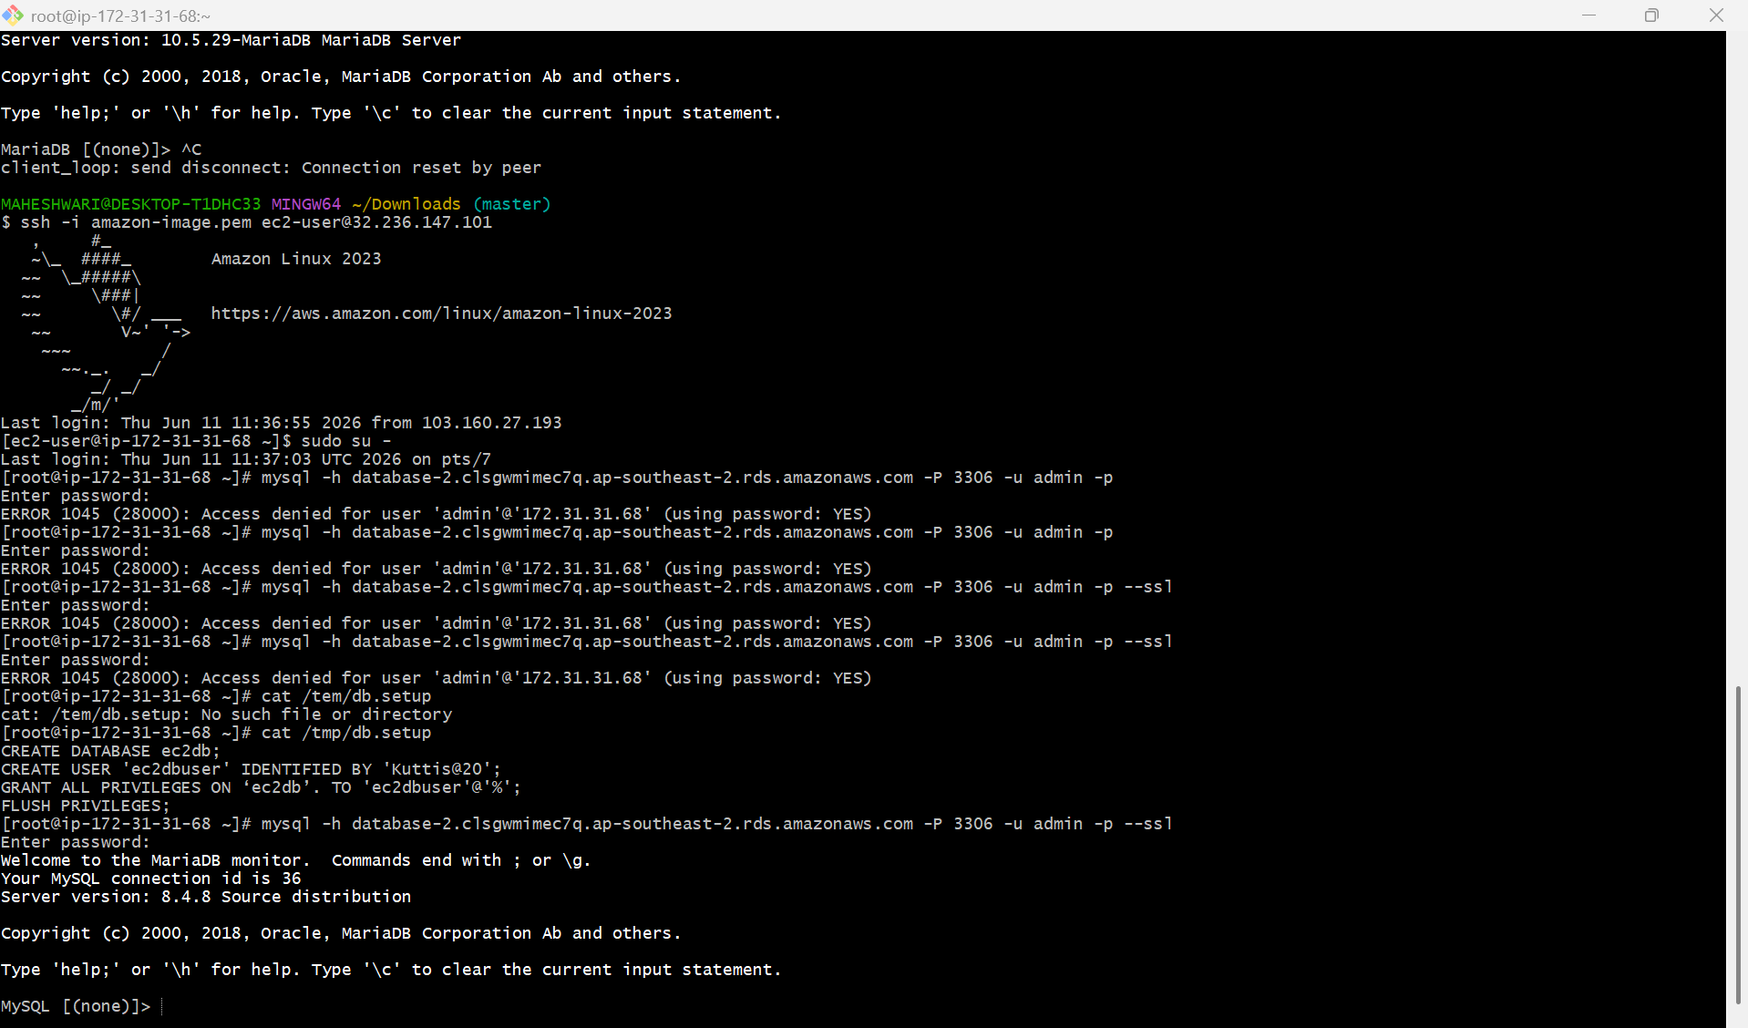

8. Configure Multi-AZ.

PURPOSE: To improve database availability and fault tolerance by maintaining a synchronous standby replica in another availability zone.

OBJECTIVE:
- Enable Multi-AZ development for an existing RDS instance.
- Ensure automatic failover during infrastructure failures.
- Increase database availability without changing the application endpoint.

PREREQUISITES:
- An existing Amazon RDS instance.
- IAM permissions to modify RDS resources.
- AWS management console access.

OUTCOME:
- Multi-AZ deployment is successfully configured.
- Standby database is created in a separate Availability Zone.
- Automatic failover capability is enabled.
- Database availability and disaster recovery readiness are improved.

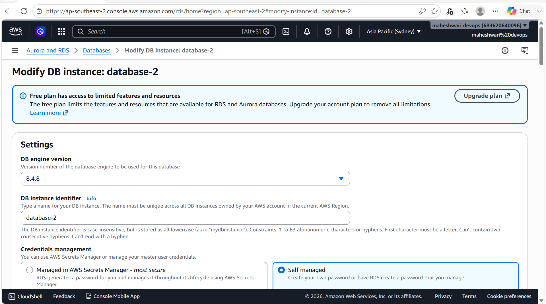


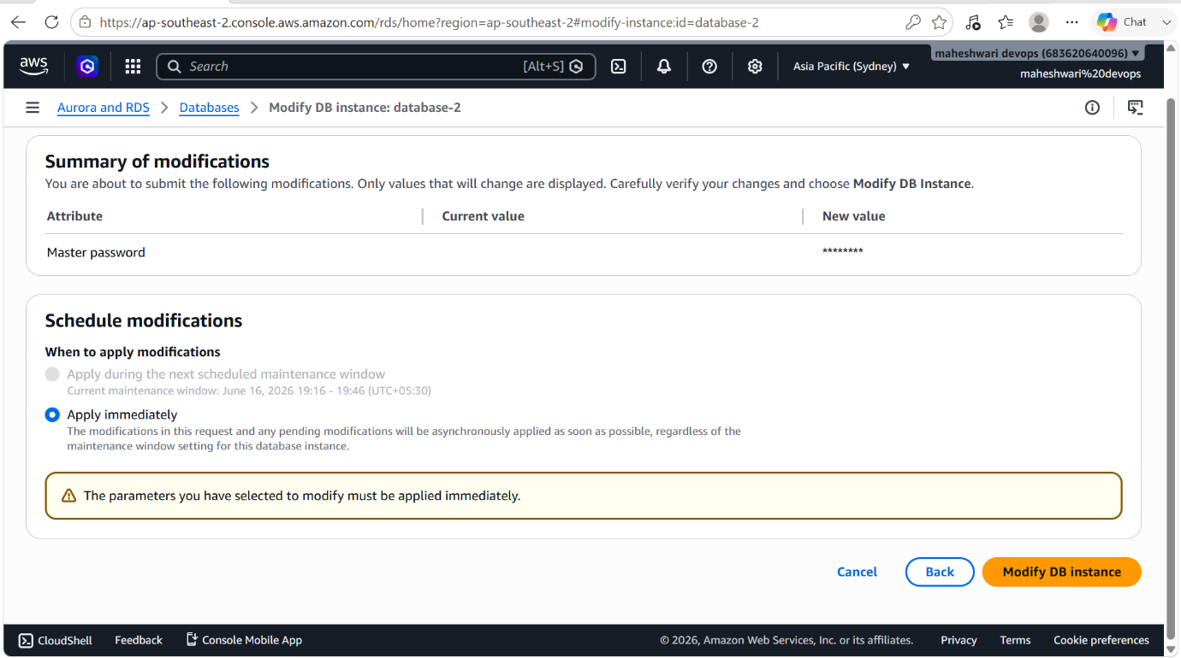

9. Take backup of DB and restore the DB.

PURPOSE: To create a backup of the MySQL database and restore it when required for disaster recovery, migration or data recovery.

OBJECTIVE:
- Create a logical backup of an RDS MySQL database.
- Store the backup file safely.
- Restore the backup into a new or existing database.

OUTCOME:
- A backup file (.sql) is created using mysqldump.
- The backup can be stored locally, on EC2, or in S3.
- The database can be restored to a new database or a new RDS instance.
- Data recovery and disaster recovery requirements are met.

STEP BY STEP IMPLEMENTATION:
- Take a snapshot of the targeted RDS instance.
- After taking snapshot, that snapshot should be restored.
- And it will create a new RDS instance.
- After creating, we have to login onto RDS instance by using endpoint provided by RDS service.

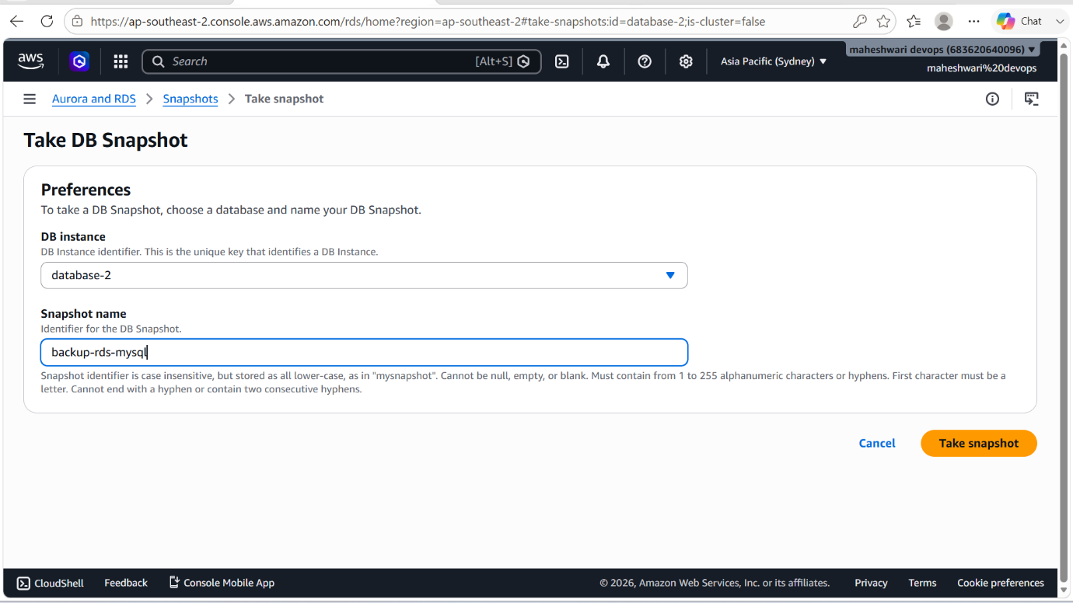

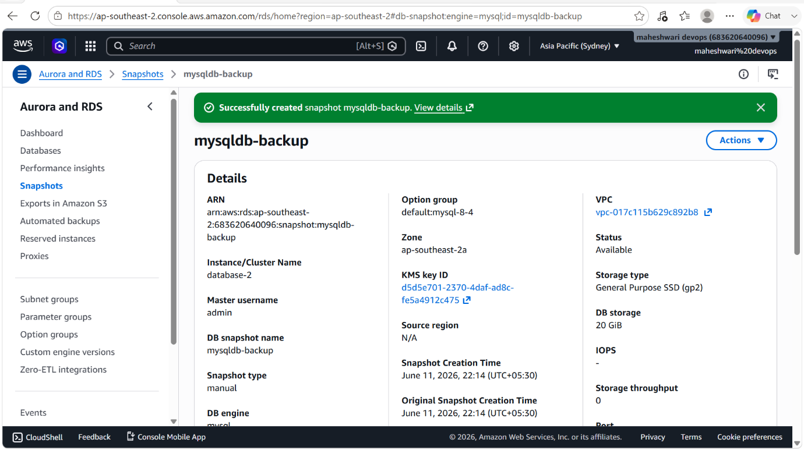

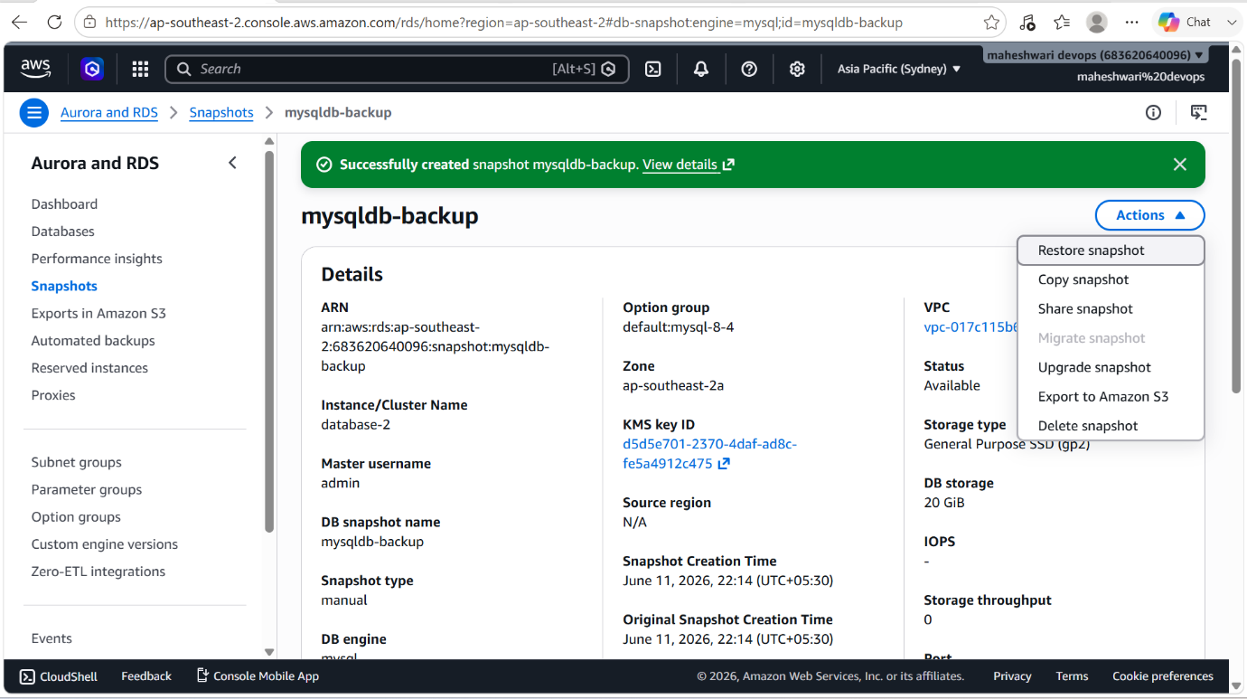

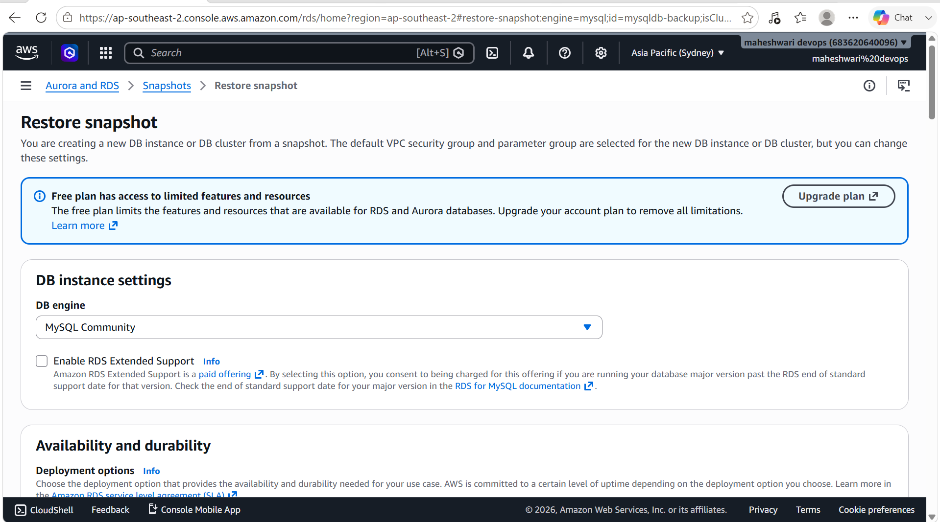



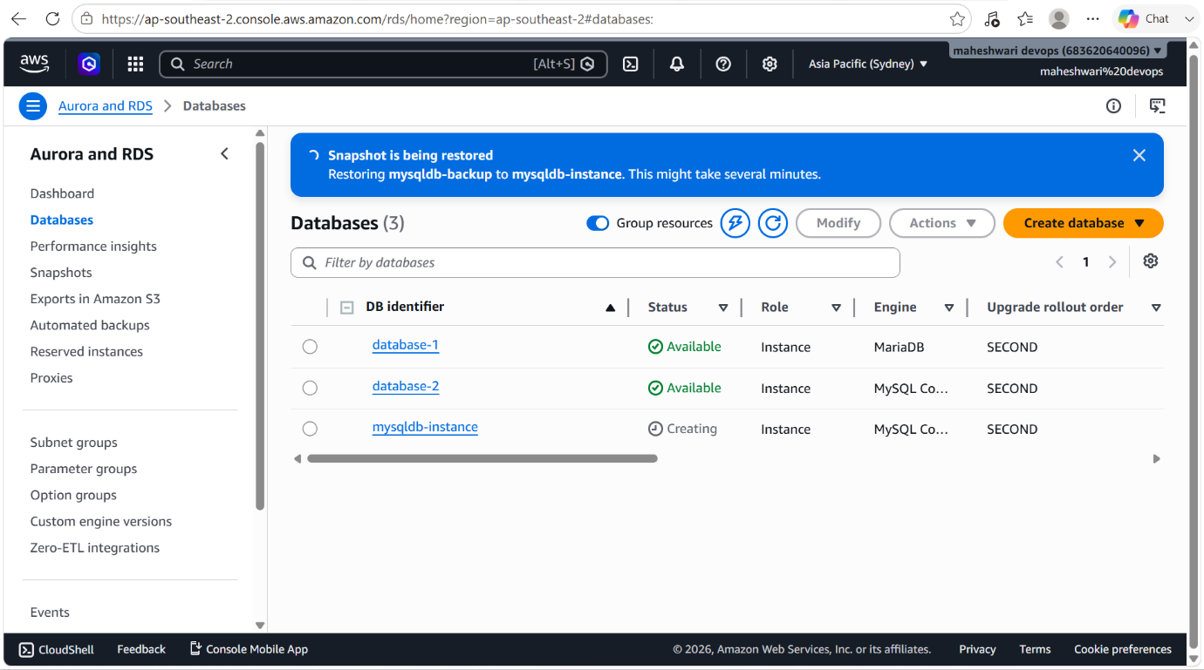

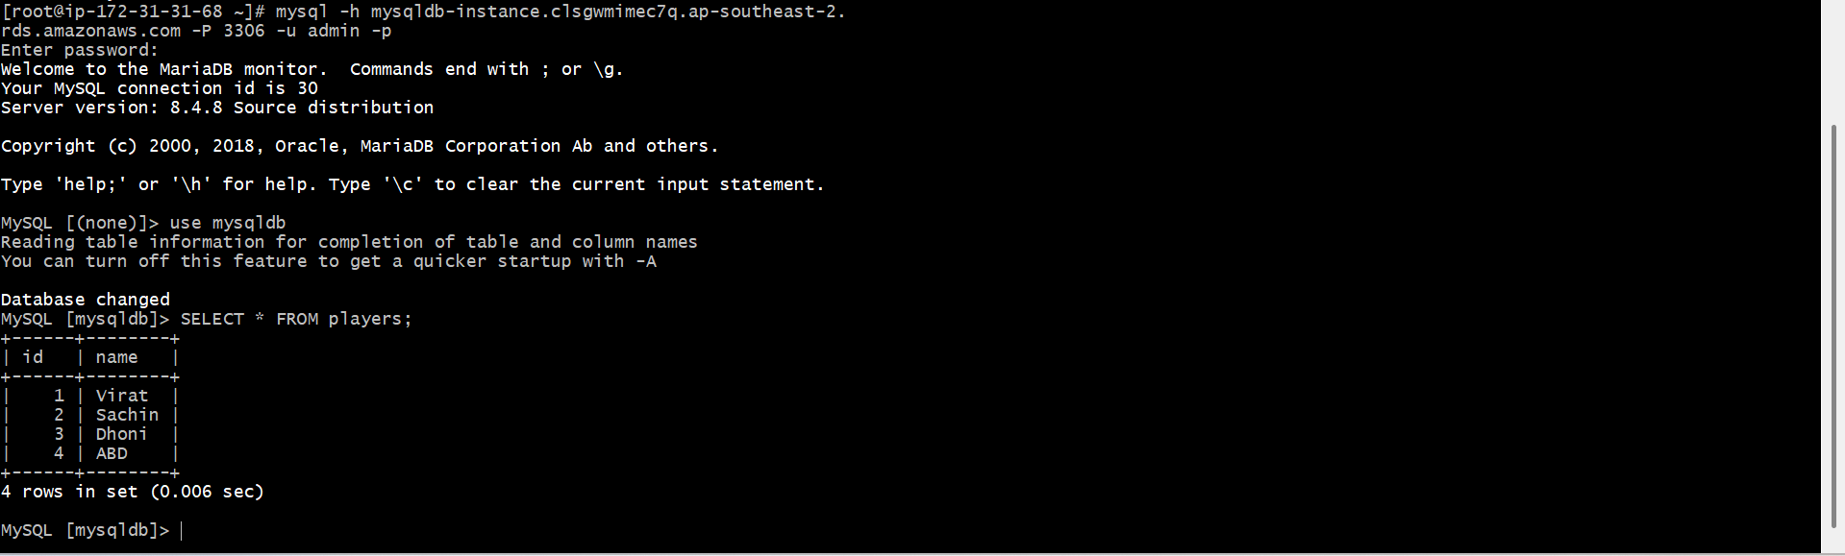

10. Create read replica.

PURPOSE: To offload read traffic from the primary database and improve application performance by creating a read-only copy of the database.

OBJECTIVE:
- Create a Read Replica for an existing RDS MySQL instance.
- Use the replica for reporting and read-intensive workloads.
- Improve database scalability and availability.

PREREQUISITES:
- Existing RDS MySQL instance.
- Automated backups enabled (Backup Retention Period > 0).
- Sufficient storage and permissions.

STEP BY STEP IMPLEMENTATION:
- When u drop down the actions, it will show the read replica option.
- Click on that option and create a read replica.

